NEWCASTLE UNITED CHURCH
84 Mill St. S. L1B 1H2 905-987-4515
newcastleunitedchurch@bellnet.ca www.newcastleunitedchurch.org
Rev. Mary-Jane Hobden, B.A., M. Div.
Joanne McLennan, A.R.C.T, L.T.C.L., Music Director
December 3, 2017 10:30 a.m.
First Sunday of Advent
“As followers of Christ, we are called to be a worshipping and learning, receiving and giving community of faith, hope and love.” – Newcastle United Church Mission Statement

* indicates please stand as able and comfortable

We Approach God

Prelude

Welcome – Our Life and Work

A Time of Centring – Lighting the Advent Candles
An Advent Adventure

Wise Ones from the East, where are you going?
Can we go too?

We have seen an amazing star.
It shines brighter than any other star.
We are going to follow this star and see where it takes us.
We think it will lead us to a child who will soon be born,
a child of God who will change the world.
We have faith that God will show us the way.
We have great hope that our quest will be successful.
And, yes, you can come with us.

Thank you, Wise Ones, for your faith and your gift of Hope.
We will join you on this Advent adventure.
(First blue candle is lit by a Wise One.)
Sung Response: (#6 “A Candle Is Burning” v. 1)
A candle is burning, a flame warm and bright,
a candle of hope in December's dark night.
While angels sing blessings from heaven's starry sky,
our hearts we prepare now for Jesus is nigh.
Call to Worship

* Hymn “O Come, O Come Emmanuel” # 1

Prayer of Approach

We Hear God’s Word

Mark 13:35-37

Hymn “Jesus Came Bringing Us Hope” MV 33

Jesus came bringing us hope,
Jesus came bringing us hope.
Jesus came bringing us hope,
hallelujah forever more!
Words & Music: Traditional song, Cameroon; arr. More Voices, 2007John L. Bell, © 1995 WGRG, Iona Community, Scotland; All rights reserved. Reprinted under ONE LICENSE #A- 727596.

A Time To Be Children
The Lord’s Prayer
Our Father, who art in heaven, hallowed be thy name.
Thy kingdom come, thy will be done
on earth as it is in heaven.
Give us this day our daily bread,
and forgive us our trespasses,
as we forgive those that trespass against us.
And lead us not into temptation, but deliver us from evil,
For thine is the kingdom, the power and the glory,
for ever and ever. Amen.

Children and leaders leave for Faith In Motion

Isaiah 64:1-9 Open the heavens and come down.
Sung Response: “Don’t Be Afraid”
Don’t be afraid. My love is stronger,
my love is stronger than your fear.
Don’t be afraid. My love is stronger
and I have promised, promised to be always near.
Words: John L. Bell & Graham Maule, Music: John L. Bell, © 1995 WGRG, Iona Community, Scotland; All rights reserved. Reprinted under ONE LICENSE #A- 727596.

Ministry of Music

Psalm 80 Shine on us, shepherd of Israel. VU Pg.794 Part 1

Mark 1:1-8 The preaching of John the Baptist.
Reader: The word of the Lord.
People: Thanks be to God.

* Hymn “There’s A Voice In The Wilderness” # 18

Message

We Respond To God’s Word

The Offertory

* Presentation of our gifts and singing verse 4 of #55

What can I give him, poor as I am?

If I were a shepherd, I would bring a lamb;

if I were a wise man, I would do my part;

yet what I can I give him - give my heart.

Dedication Prayer (unison)
God, you come to us in so many ways. You are in our hearts and we in your embrace. Through these gifts, may hearts be warmed, hands be held, and care extended around your world. Amen.

Prayers of the People

* Closing Hymn “Hark! The Herald Angels Sing” # 48

* Commissioning and Benediction

* Sung Blessing “Come, Thou Long Expected Jesus” #2
Come, thou long-expected Jesus,
born to set thy people free:
from our fears and sins release us,
let us find our rest in thee.

Israel's strength and consolation,
hope of all the earth thou art,
dear desire of every nation,
joy of every longing heart.

Postlude

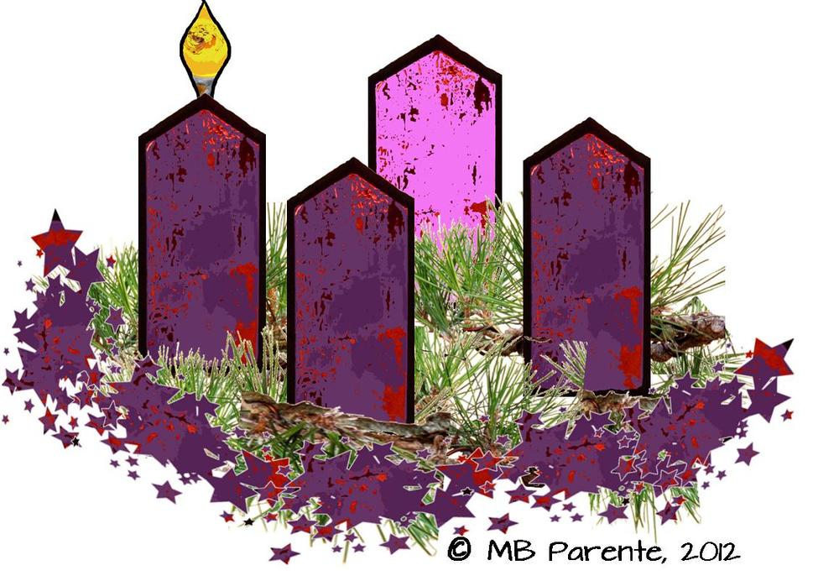

Advent I - Hope
Newcastle United Church

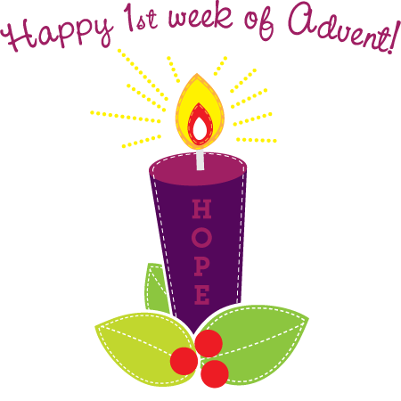
Welcome! We enjoy open seating so please, sit where you feel comfortable, and meet a new friend. We are happy you have chosen to worship with us. Please sign our guest book located in the narthex, and we invite you to join us again.

Kindly remember there are people here who are highly allergic to scents and to peanuts/tree nuts. Thank you for your consideration.

Greeting you this morning are Eve-Ann and Brian Reid.

Faith In Motion – during Advent, our young people 5-12 years are learning the meaning of carols. This week is “Joy to the World!”. Bible Point: God has a plan. Key Scripture: Isaiah talks about a Saviour King – Isaiah 9: 2-7.
re:form! – our teens dig into “Why do Christians believe Christianity is the best religion?”

2018 Church Envelope sets are available in the narthex. If you wish to receive a set, please let Lorna know 905 987 3940.

Thank you to our Christmas “Elves” – Tim, Susan, Jewel and Faith for getting and decorating our tree and sanctuary and the homemade shortbread!

Faith In Motion young people are staying for a bit after church to practice our Christmas Eve presentation. All young people are welcome to participate. We have many non-speaking parts!

Bible Study – Our Wednesday morning Bible Study meets at 9:30 am. Everyone is welcome.
Scriptures for Next Week: Isaiah 40:1-11; Ps, 89:1-4, 19-26; John 1:6-8, 19-28

M&S Bows – if you would like to make an extra contribution toward the Mission & Service fund through an Advent Bow, please mark “Bows” on your envelope: Green– to $25; Red to $50; Silver – to $100; Gold – $100+.

In Memoriam Poinsettias – please speak with Carole Brunton or Jean Rancier if you would like to have a plant placed in the sanctuary.

Official Board Meeting – Tuesday, December 5, 2017 at 7 pm. This is our usual quarterly meeting.
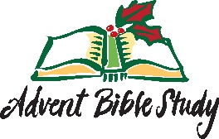
ADVENT STUDY –We are looking at how history has impacted our reading of the nativity story. Come and take a look at the nativity story again, as if for the first time, and see what the gospels are really teaching us about Jesus’ birth. Monday evenings, Dec. 4, 11 and 18 beginning at 7 pm. Please read the first two chapters of the Gospels of Matthew and Luke and see what they tell us about the world into which Jesus was born.
Loved by Santa Paws Pet Treats! will be available for pick-up next Sunday.
Baked Potato Bonanza! The Choir’s Christmas Cantata is Sunday morning on December 17. As a fundraiser, the Stewards are hosting an after-service lunch of baked potatoes and sweet potatoes with toppings galore! Sign-up sheets are posted in the hall and narthex so we know how many to buy. If you have a topping you’d like to share, bring it along that Sunday. Thank you!
Community Carol Fest – Thursday, December 7 at 7PM here at Newcastle United. With musicians from our church, St. Francis of Assisi and St. George’s Anglican. Freewill offering with proceeds to the Clarington East Food Bank. Refreshments following.
Advent and Christmas Services:
Sunday, December 10 – Advent 2 – regular morning service
Sunday, December 17 – Advent 3 – Choir Cantata
during regular morning service
Sunday, December 24 – Advent 4 – regular morning service
Sunday, December 24 – Christmas Eve – 7 pm service
Sunday, December 21 – First Sunday of Christmas – regular
morning service

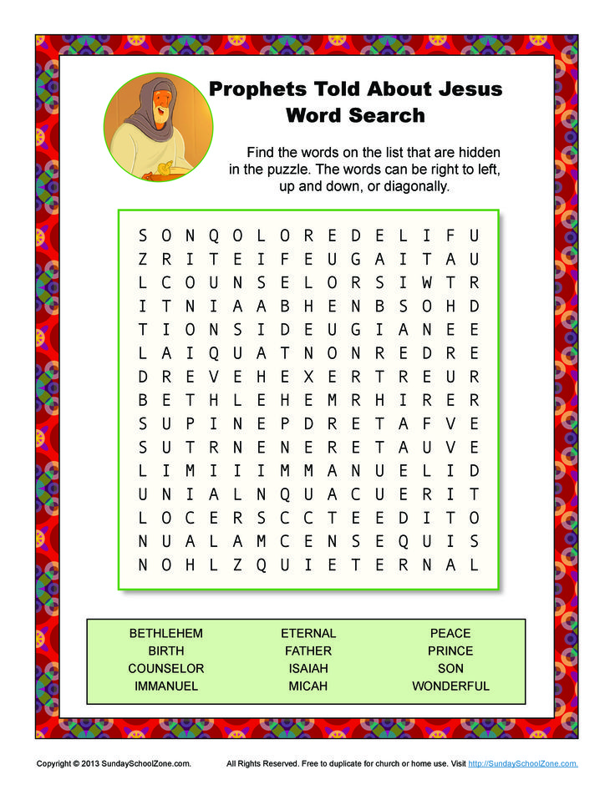

Announcements
December 3, 2017

CHURCH OFFICE INFORMATION
Week of December 4, 2017
HOURS: Lorna is in the office Fridays from 9 am to 1 pm.

Minister’s office hours: Monday: 1-5 pm and Wednesday: 11-3. Please note: These hours are subject to change due to emergencies.

BULLETIN ANNOUNCEMENTS: Please have all announcements for the bulletin to the office by Thursday at 10 am.

Music outside Voices United printed, with permission, under One License #A-727596
Advent Candles – Written by Susan Lukey, Gathering, A/C/E 2017/18, p. 68. Used with permission.

