NEWCASTLE UNITED CHURCH
84 Mill St. S. L1B 1H2 905-987-4515
newcastleunitedchurch@bellnet.ca www.newcastleunitedchurch.org
Rev. Mary-Jane Hobden, B.A., M. Div.
Joanne McLennan, A.R.C.T, L.T.C.L., Music Director
November 26, 2017 10:30 a.m.
Reign of Christ Sunday - Communion
“As followers of Christ, we are called to be a worshipping and learning, receiving and giving community of faith, hope and love.” – Newcastle United Church Mission Statement

* indicates please stand as able and comfortable

We Approach God

Prelude and Lighting the Christ Candle

Welcome – Our Life and Work

A Time of Centring – Take, O Take Me As I Am
Take, O take me as I am;
summon out what I shall be;
set your seal upon my heart and live in me.
Words & Music: John L. Bell and Graham Maule, © 1995 WGRG, Iona Community, Scotland
All rights reserved. Reprinted under ONE LICENSE #A- 727596.
As children and leaders leave for Faith In Motion

Call to Worship

* Hymn of Praise “Rejoice, The Lord Is King” # 213

Prayer of Approach

We Hear God’s Word

Ezekiel 34:11-16, 20-24 God searches and judges. Pew Bible Pg. 702

Ministry of Music “Thy Will Be Done” by Joyce Elaine Eilers

Matthew 25:31-46 When you helped me. Pew Bible Pg. 807
Reader: The word of the Lord.
People: Thanks be to God.

* Hymn “When I Needed A Neighbour” # 600

Message

We Respond To God’s Word

The Offertory

* Presentation of our gifts and singing verse 1 of # 218

We praise you, O God, our Redeemer, Creator;

in grateful devotion our tribute we bring.

We lay it before you; we kneel and adore you;

we bless your holy name, glad praises we sing.

Dedication Prayer

Invitation To The Table

* Hymn “Eat This Bread And Never Hunger” # 471

Prayer of Great Thanksgiving
God be with you.
And also with you.
Lift up your hearts.
We lift our hearts in prayer.
Let us give thanks to God.
It is good to give God thanks and praise.
We give you thanks … heaven and earth to give you praise:
Lord of lords, Creator of all things, nature gives thanks,
your creatures give thanks. Your praise rises in us like the great river. God of all things, Creator, Provider, we thank you in the name of Jesus the Christ.
Let us remember together that vision of God’s reign
shown to us in Jesus at table:
he shared food with followers and friends,
with saints and sinners,
with crowds of thousands on the hillside,
and a few friends in an upper room.
On the night before he died,
he had supper with his companions.
He took a loaf of bread, and after giving thanks,
he broke it, and gave it to them, saying:
“Take, eat. Do this in remembrance of me.”
Then, he took a cup, and after giving thanks,
he passed it among them, saying:
“Drink this. Do this in remembrance of me.”
Through this loaf and cup, Jesus lives within us.
In word and deed, Jesus lives among us.
God of majesty … Word of life.
We remember Jesus, faithful friend and living hope:
attesting truth before the powers; seeking the forgotten and abused; setting the prodigal and the righteous at the one feast of forgiveness. We remember Jesus, risen and eternal One, Christ who comes to meet us.
By what we do here, we proclaim the mystery of faith:
Christ has died. Christ is risen. Christ will come again.
Send, O God ... Into the prayer Jesus taught us…
Our Father, who art in heaven, hallowed be thy name. Thy kingdom come, thy will be done on earth as it is in heaven.
Give us this day our daily bread, and forgive us our trespasses, as we forgive those that trespass against us.
And lead us not into temptation, but deliver us from evil,
For thine is the kingdom, the power and the glory, for ever and ever. Amen.

Breaking The Bread and Lifting The Cup
Sharing The Bread and Cup

Prayer After Communion (unison)
Healer, Unifier, Ruler, Servant, Saviour, in your name, we have eaten. By you Spirit, we have been blessed. Grant that we who have received the gift of your feast may be ready to be gifts in your name to your world. Amen.
(Written by Elaine Bidgood Sveet, Gathering, Pentecost 2 2017, p. 50. Used with permission.)

M &S Bows and Gifts With Vision

* Closing Hymn “Make A Joyful Noise” # 100

* Commissioning and Benediction

* Sung Blessing “Go Now In Peace” (inside cover of hymnbook)

Postlude

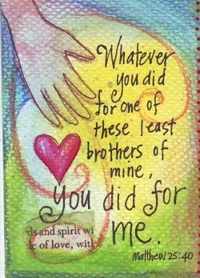

Newcastle United Church

Welcome! We enjoy open seating so please, sit where you feel comfortable, and meet a new friend. We are happy you have chosen to worship with us. Please sign our guest book located in the narthex, and we invite you to join us again.

Greeting you this morning are Judy and Myno Van Dyke. Judy is a member of the U.C.W. and BIBLOS co-ordinator and Myno is Co-ordinator of the Men’s Breakfast Group.

Our BIBLOS reader is Sue Johnson.

Faith In Motion – our young people 5-12 years are learning about and doing activities on Reign of Christ Sunday.
re:form! – our teens dig into “Why do Christians believe Christianity is the best religion?”

2018 Church Envelope sets are available in the narthex. If you wish to receive a set, please let Lorna know 905 987 3940.

Bible Study – Our Wednesday morning Bible Study meets at 9:30 am. Everyone is welcome.

Scriptures for Next Week: Isaiah 64:1-9; Psalm 80:1-7, 17-19; Mark 1:1-8
Cheese order forms are available in the narthex (church entry). Last date to order is today, Nov. 26, with delivery Dec. 6. Fundraiser from the Stewards. Prices are not on order form, however are comparable to those in grocery stores. Please leave completed forms in box in narthex. Let your friends know too! Thank you.

Coffee Plus following worship. Thank you to all who remembered our local Food Bank this morning.

M&S Bows – if you would like to make an extra contribution toward the Mission & Service fund through an Advent Bow, please mark “Bows” on your envelope: Green– to $25; Red to $50; Silver – to $100; Gold – $100+.

Thursday, November 30 – if you would like to help us decorate the sanctuary Christmas tree, please come to the church for 10AM. We appreciate your help!
Budget Cte. Meets Thursday, November 30 at 10AM in the hall meeting room.
In Memoriam Poinsettias – please speak with Carole Brunton or Jean Rancier if you would like to have a plant placed in the sanctuary.

Official Board Meeting – Tuesday, December 5, 2017 at 7 pm. This is our usual quarterly meeting.

ADVENT STUDY – This year we will be looking at how history has impacted our reading of the nativity story. Inspired by the book, “The First Christmas” by Marcus Borg & Dominic Crossan, come join Rev. Mary-Jane and take a look at the nativity story again, as if for the first time, and see what the gospels are really teaching us about Jesus’ birth. Monday evenings, Nov. 27, Dec. 4, 11 and 18 beginning at 7 pm.
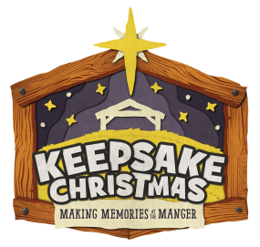
Loved by Santa Paws Pet Treats! Some of our teens are rolling up their sleeves after Coffee Plus today to make the pet treats. Thanks to all who ordered from us for our fundraiser.
ADVENT EVENT – Keepsake Christmas
Join us on Saturday, December 2 from 2-4PM as we hear the story of our Saviour’s birth from Mary, Joseph and Gabriel, interact with our guide and sing some favourite carols while making your very own manger set. We cap our time together off with some refreshments. This event is for all. Sign-up sheets are in the church entry and hall. Today is last day to sign-up. An Outreach Project from Faith In Motion young people & their leaders.
Baked Potato Bonanza! The Choir’s Christmas Cantata is Sunday morning on December 17. As a fundraiser, the Stewards are hosting an after service lunch of baked potatoes and sweet potatoes with toppings galore! Thanks to our volunteers who are helping with this as most of the Stewards are Choir members. Sign-up sheets are posted in the hall and narthex so we know how many spuds and yams to buy. If you have a topping you’d like to share, bring it along that Sunday. Thank you!
Community Carol Fest – Thursday, December 7 at 7PM here at Newcastle United. With musicians from our church, St. Francis of Assisi and St. George’s Anglican. Freewill offering with proceeds to the Clarington East Food Bank. Refreshments following.

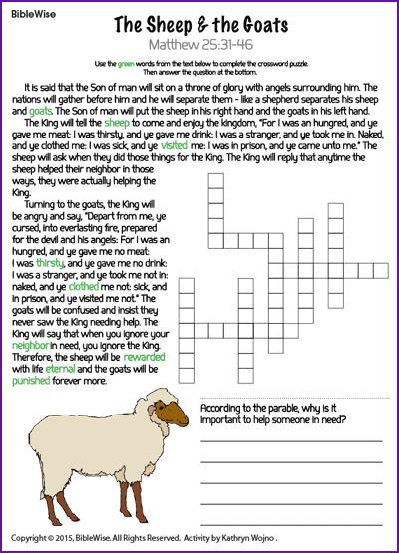

Announcements
November 26, 2017

CHURCH OFFICE INFORMATION
Week of November 27, 2017
HOURS: Lorna is in the office Fridays from 9 am to 1 pm.

Minister’s office hours: Tuesday and Thursday: 9:30-1:30. Please note: These hours are subject to change due to emergencies.

BULLETIN ANNOUNCEMENTS: Please have all announcements for the bulletin to the office by Thursday at 10 am.

Music outside Voices United printed, with permission, under One License #A-727596

