NEWCASTLE UNITED CHURCH
84 Mill St. S. L1B 1H2 905-987-4515
newcastleunitedchurch@bellnet.ca www.newcastleunitedchurch.org
Rev. Mary-Jane Hobden, B.A., M. Div.
Joanne McLennan, A.R.C.T, L.T.C.L., Music Director
October 15, 2017 10:30 a.m.
The Season of Pentecost
“As followers of Christ, we are called to be a worshipping and learning, receiving and giving community of faith, hope and love.” – Newcastle United Church Mission Statement

* indicates please stand as able and comfortable

We Approach God

Prelude and Lighting the Christ Candle

Welcome – Our Life and Work

A Time of Centring – Lord, Prepare Me to Be a Sanctuary
Lord, prepare me to be a sanctuary,
pure and holy, tried and true;
with thanksgiving, I’ll be a living
sanctuary for you.
Words & Music: John W. Thompson & Randy Scruggs, © 1982 Whole Armor & Full Armor Publishing Companies; All rights reserved. Reprinted under ONE LICENSE #A- 727596.

Call to Worship (responsive) (inspired by Philippians 4:4-9)
Rejoice in the Lord always.
The Lord is near.
Let your gentleness show in your treatment of people.
The Lord is near.
Bring all your anxiety and prayers to God.
The Lord is near.
The God of peace will be with you. Let us worship God.

* Hymn of Praise “Come, We That Love The Lord” # 715

Prayer of Approach (unison)
We rejoice, O God, that we can come to you in prayer and know you are near. We can bring our joys and anxieties and know you hear. May this time of worship quiet our minds, renew our Spirits and prepare us for the days ahead. Amen.

We Hear God’s Word

Ministry of Music: “God’s Mercy”- words by Frederick W. Faber, music by Larry Shackley

Matthew 22:1-2 & Philippians 4:4-5

* Hymn “Draw The Circle Wide” (see insert)

A Time To Be Children
The Lord’s Prayer
Our Father, who art in heaven, hallowed be thy name.
Thy kingdom come, thy will be done
on earth as it is in heaven.
Give us this day our daily bread,
and forgive us our trespasses,
as we forgive those that trespass against us.
And lead us not into temptation, but deliver us from evil,
For thine is the kingdom, the power and the glory,
for ever and ever. Amen.

Song “You Shall Go Out With Joy” # 884
As children and leaders leave for Faith In Motion

Exodus 32:1-14 The golden calf. Pew Bible Pg. 69

Isaiah 25:1-9 God provides. Pew Bible Pg.568

Matthew 22:1-14 Violence at the wedding banquet. Pew Bible Pg.803
Reader: The word of the Lord.
People: Thanks be to God.

* Hymn “God Reveal Your Presence” # 391

Message

We Respond To God’s Word

The Offertory

* Presentation of our gifts and singing verse 1 of # 218

We praise you, O God, our Redeemer, Creator;

in grateful devotion our tribute we bring.

We lay it before you; we kneel and adore you;

we bless your holy name, glad praises we sing.

Dedication Prayer (unison)
Amen.

Prayers of the People

* Closing Hymn “What A Friend” # 664

* Commissioning and Benediction

* Sung Blessing “Go Now In Peace” (inside cover of hymnbook)
Words & Music: Besig/Price, © 1988 Shawnee Press; All rights reserved. Reprinted under ONE LICENSE #A- 727596.

Postlude
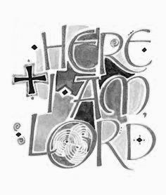

Welcome! We enjoy open seating so please, sit where you feel comfortable, and meet a new friend. We are happy you have chosen to worship with us. Please sign our guest book located in the narthex, and we invite you to join us again.

Greeting you this morning are Diana and Verne Rowe, members of the Congregational Life Committee.

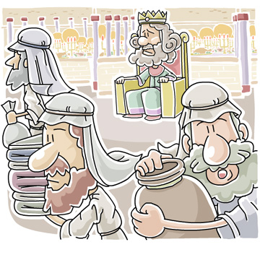
“everything is ready; come to the wedding banquet”

Newcastle United Church

Just a Reminder: We have members of our congregation who are extremely sensitive to fragrances. Please consider these folks and come to church Scent Free. Thank you for your consideration. Please remember we are a peanut/hazel nut free zone. Thank you.

Our BIBLOS reader is Myno Van Dyke, Men’s Breakfast Group Co-ordinator.
Faith In Motion – Holy Moly! - our 5-8 year olds are learning about Paul is Shipwrecked – Through storms, snakes and sickness, Paul’s faith saves the day. Key Bible verse is Acts 27: 24.
Grapple! our young people to 12 years are exploring “What Really Matters – What’s the point?” Point: it’s about a growing relationship with Jesus. Passages: Luke 10: 38-42; 11: 37-42.
re:form! – our teens complete “Why did Jesus get baptized?” and begin “Is believing in Jesus really the only way to get to heaven?” Scriptures: John 3: 5-6; John 14: 6; Romans 10:9.

The sympathy and prayers of the congregation are extended to Lynda Crowther, family and friends on the passing of Charles on Thursday. The service is at our church, 1PM on Tuesday, October 17 from 11AM-1PM. Masonic service at 12:45PM.
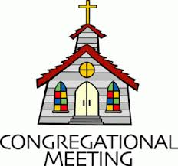
Congregational Meeting – today following worship to discuss the report/proposal of the Hall Assessment Committee received by the official Board. This is a conversation on the physical and technical information provided. No decisions will be expected at this meeting.

Bible Study – Our Wednesday morning Bible Study meets at 9:30 am. Everyone is welcome.

Spiritual But NOT Religious? – We are providing an evening of conversation for those who are seeking spiritually to connect with something, but who do not expect to find it among the pews. If you know someone like this please let them know about this evening, Wednesday, October 18 beginning at 7 pm at The Snug.

Friendship Connection – all ladies are welcome to join us on Thursday, October 19 at 11:30AM at Castle John’s. Sign-up sheets are posted in the narthex (church entry) and hall.

Choir Practice – Thursdays at 7 pm. New members are always welcome.

Euchre - the Stewards host Euchre Night on Friday, October 20 at 7PM. $5/person includes refreshments. All are welcome.

Stewards Meeting – following worship on Sunday, October 22.

New Members – We will be celebrating and welcoming new members to the congregation on Sunday, October 29.

Official Board Meeting – Monday, October 30 at 7 pm.

Scriptures for Next Week: Exodus 33:12-23; Psalm 99; Matthew 22:15-22

Roast Beef Dinner- Sunday, November 5 at 5:30PM.
The Stewards, with much appreciated help from the congregation, will host this dinner in celebration of our church congregation’s 193rd anniversary. Sign-up sheets are posted in the hall and narthex. Tickets are available from the Stewards: adults $20, young people to age 12 $10, 6 and under free, family of 2 adults and 2 young people $50. Thanks for supporting this large fundraising project for the operating expenses of our church.

From the Stewards: we have received with thanks, donations to date, toward cost of sanctuary air conditioners: $4100.00.

Friday, October 27 – Faith In Motion hosts a Spooky Theme Games Night from 7-9PM. Free! Snacks! Everyone is welcome.

The next Men's Breakfast is on Saturday October 28 at Newcastle United Church. Gus from Massey House Restaurant will be cooking us another great breakfast- the speaker is Myno VanDyke. His topic is the story of two local veterans-- Venton and Kilpatrick. Start time is 0830 and cost is $10 payable at the door. Please advise Myno if you are attending so we will have an accurate number for Gus.
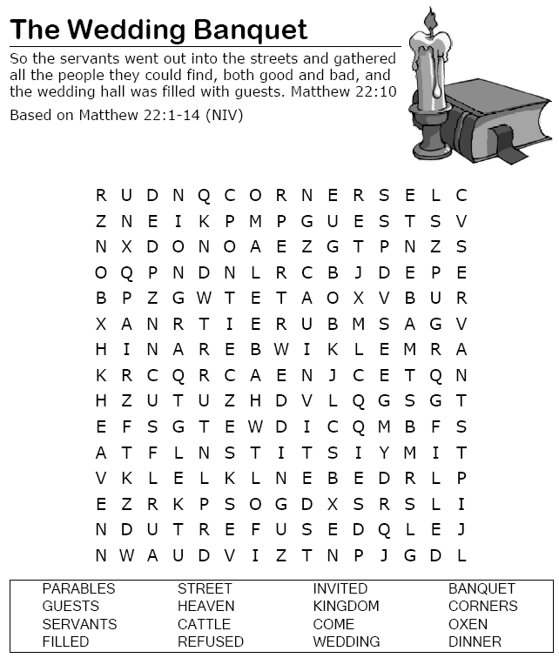

Announcements
October 15, 2017

CHURCH OFFICE INFORMATION
Week of October 16, 2017
HOURS: Lorna is in the office Fridays from 9 am to 1 pm.

Minister’s office hours: Monday and Tuesday: 9:30-1:30. Please note: These hours are subject to change due to emergencies.

BULLETIN ANNOUNCEMENTS: Please have all announcements for the bulletin to the office by Thursday at 10 am.

Music outside Voices United printed, with permission, under One License #A-727596

